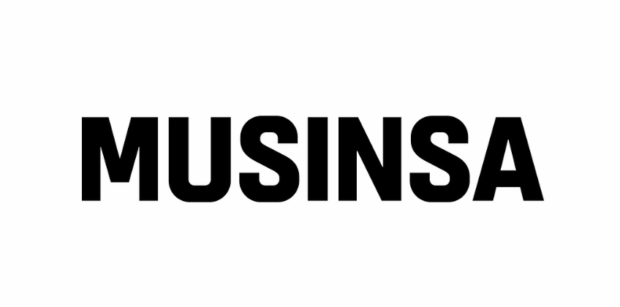

프로젝트 | UI 선호도 조사 - 미국 | 참여자 | 2
인터뷰어 | AI 인터뷰어 | 날짜 / 방식 | — / 비대면

AI  00:00 | Hello and welcome. My name is Proby, and I will be conducting the interview today. Please feel free to share your honest opinions.
참여자  00:00 | Hey, I'm I'm ready.
AI  00:00 | Do you usually pay a lot of attention to fashion?
참여자  00:00 | Yeah, uh, I pay a, uh, a lot of attention to fashion. I like keeping up with new trends, checking out new drops, and, uh, putting outfits together.
AI  00:00 | Do you have your own personal fashion style that you pursue? What is your favorite fashion style usually? You can describe it in terms of items or specific areas.
참여자  00:00 | Um, I definitely have my own style. I lean towards a clean streetwear look with some athletic influence. Um, I usually go for a fitted tees, hoodies, and jackets paired with jeans or joggers. Um, big on sneakers, uh, so I'll build outfits, uh, around those. Uh, I like neutral colors most of the time, but I'll mix in something bold, occasion, uh, occasionally to keep it from looking too basic.
AI  00:00 | You mentioned you like clean streetwear with athletic influences, often wearing fitted tees, hoodies, jackets, jeans or joggers, and sneakers, with a preference for neutral colors but occasional bold pieces. For these items, how do you typically go about purchasing them, and are there any specific factors you prioritize when buying each type?
참여자  00:00 | I I usually start by browsing apps like Nike, ASOS, or Zara. To see new drops and, uh, trending items. So if something catches my eye, I'll check reviews, uh, sizing, and photos to make sure it fits the look I'm looking for. Uh, for sneakers, I I pay closer attention and sometimes, uh, compare cross-apps like GOAT and StockX. Uh, once I'm confident, I usually purchase direct through the app, especially if there's a deal or a limited release.
AI  00:00 | You mentioned browsing apps like Nike, ASOS, and Zara, checking reviews, sizing, and photos. For fitted tees, hoodies, jackets, jeans, or joggers, are there any specific factors you prioritize when buying them?
참여자  00:00 | For the fit is probably the biggest thing for me, especially for tees and hoodies. So I always check size, sizing guides, and reviews. Uh, quality material, quality of material matter too. So I don't want soft shrinking or losing shape after a few washes. Um, I also look at how versatile it is. If it if I can wear it with multiple outfits. Price plays a role, but I'm willing to pay more if it looks good and lasts. And for sneakers, I care a lot about style and how they'll pair with what I have already have.
AI  00:00 | What fashion apps do you usually use?
참여자  00:00 | I mostly use Nike, ASOS, Zara, and H&M for everyday stuff like tees, hoodies, and jackets. For sneakers, I'll use GOAT and StockX pretty regularly. I also browse Shein, sometimes if I'm just looking for something quick or trying to out a different style.
AI  00:00 | You mentioned using Nike, ASOS, Zara, and H&M for everyday items. What makes you choose these specific apps for things like tees, hoodies, and jackets?
참여자  00:00 | I like the apps because they're easy to use and always have a good mix of styles that fit what I'm looking for. Um, Nike's my go-to for anything athletic or clean basics. Um, and I just trust the quality. ASOS has a ton of variety, so it's good when I want more options or something a little different. Um, Zara and H&M are solid for affordable on-trend pieces that still, uh, look put together. So between all of them, I I can usually find something that fits my style without overthinking it.
AI  00:00 | Among the fashion apps you use, have you encountered any that felt 'most convenient to use' or 'most intuitive'?
참여자  00:00 | Uh, Nike, ASOS, they feel the most intuitive to me. Nike is super clean and easy to navigate. I like how quick it is to check out, uh, and track orders. ASOS is great for, like, browsing since the filters are really detailed, so it's easy to narrow things down by fit, style, and, uh, brand. Uh, both make the whole thing whole process feel smooth without having to dig around too much.
AI  00:00 | You mentioned that Nike and ASOS feel the most intuitive. What specific features or aspects of those apps contribute to that feeling of ease and intuitiveness for you?
참여자  00:00 | I would say for Nike, it's how clean and simple everything is. Uh, the layout is straightforward, categories is, uh, it makes sense. The and checkout is really quick. I also like the way they show product details, clear photos, sizing info, and, um, the availability without digging around. For ASOS, the filters are a big reason I can narrow things down by size, filter, or excuse me, fit, color, brand, and even style pretty fast. Um, the product pages are also helpful with multiple photos, videos, and reviews. Uh, so I feel more confident before buying.
AI  00:00 | The screen you see now is the Home Screen of a fashion app service. You must choose and use only one of these three versions. Which version would you like to choose and try? Please read the yellow code name exactly.
참여자  00:00 | Let's go with G.
AI  00:00 | You chose G. Could you tell me more about what specifically you liked about its design, such as the size of the text or images, the layout, font, or colors?
참여자  00:00 | I like that it feels really clean, easy to scan. The text is a good size, not too small, so it's easy to read quickly, and the images are big enough to actually see the products clearly. Um, the layout feels organized with clear sections, so nothing looks cluttered. I also like the color balance. It's not overwhelming. And the highlight, uh, the highlights like discounts or promos stand out without having to, uh, being too aggressive.
AI  00:00 | The screen you see now is the Product Detail Screen of a fashion app service. You must choose and use only one of these three versions. Which version would you like to choose and try? Please read the yellow code name exactly.
참여자  00:00 | Um, something in G, you know. Uh, the focus is on the product without feeling cluttered. Uh, the main engine is the main image is, uh, large and clear, which makes it easy to see the details right away. The text is clean and readable. Um, they use key info like the product name and price, which is easy to find without digging. So I like the they have the add a bag button placement. It starts and it stands out but doesn't take up the whole screen.
AI  00:00 | The screen you see now is the Search Bar Screen of a fashion app service. You must choose and use only one of these three versions. Which version would you like to choose and try? Please read the yellow code name exactly.
참여자  00:00 | Still sticking with G. It makes a good guidance without feeling overwhelming. Uh, the recent searches and most search brands help me quickly jump back into things I've, uh, I'll, I'll look at before, which saves times. I also like having, uh, popular categories right there since it makes browsing easier if I'm, uh, even if I'm not searching for something specific.
AI  00:00 | The screen you see now is the Category Screen of a fashion app service. You must choose and use only one of these three versions. Which version would you like to choose and try? Please read the yellow code name exactly.
참여자  00:00 | I like G again just because, like, the new season sale, then the yellow pops off really quick. It grabs my attention. There's more categories, uh, than there is in the other one. Um, The, you know, tops all tops. It just feels like it's starts general and then goes in deeper.
AI  00:00 | The screen you see now is the Search Results Screen of a fashion app service. You must choose and use only one of these three versions. Which version would you like to choose and try? Please read the yellow code name exactly.
참여자  00:00 | G. Uh, it looks more organized. It has the sale information. Um, and I can filter by which sale options are there as well.
AI  00:00 | The screen you see now is the shopping cart screen of a fashion app service. You must choose and use only one of these three versions. Which version would you like to choose and try? Please read the yellow code name exactly.
참여자  00:00 | I think I like G better still. Uh, it just feels it shows my discounts being applied better. Uh, it's easier to understand. It doesn't feel gimmicky and not overwhelming.
AI  00:00 | The screen you see now is the Musinsa fashion app. Let's imagine that the designer of this app wants to revamp its design, but this person is not American and therefore doesn't understand American sensibilities or values. In this situation, could you provide recommendations to this designer on what elements must be included in a fashion app preferred by American users?
참여자  00:00 | Um, you know, you got to focus on making it fast and clear and confidence building. Keep the layout simple, easy to scan. Uh, big product images, clear pricing. Obvious, uh, buttons. Uh, like add to cart. Matter a lot. And then, uh, it filters are very important. It lets users, uh, sort by size, fit, brand. Uh, Americans expect to narrow things down quickly, especially on mobile. Uh, make sure the reviews and ratings are real. Um, you want to have those for people that, uh, want to they need to trust you. So the reviews need to be actually real. And then you need to make deals and promos visible. Um, people like to get, uh, deals. So they want to see the discounts always. And then you should have fast checkout, guest checkout, uh, PayPal, options, all that, um, to make convenience there for the people. And personalization helps. So show recommended items, recently viewed, and trending style so it feels tailored without being overwhelming.
AI  00:00 | You've mentioned several important elements like speed, clear layouts, big product images, filters, real reviews, visible deals, and personalization. Could you elaborate on the cultural or emotional reasons why these specific elements resonate particularly well with American users?
참여자  00:00 | I mean, it's I feel like it's not just for American users, but for any kind of user, right? Um, it comes down to convenience, trust, and control. People want to use things being fast and efficient in general. So when an app's, uh, slow or cluttered, it feels frustrating right away. Clean layout and big images let them make decisions without thinking too hard. Um, there's also the big focus on independence and control. So filters, sorting, and personalization gives users the feeling that they're in charge and of their experience instead of being guided too much. Um, then you have the trust factor. A lot of people are skeptical of markings. So they rely heavily on real reviews and photos and ratings from other buyers. Yeah. And then even if someone can afford something, they still want to feel like they're getting a good deal. So you need to have your discounts and there's also convenience. The fast checkout saved info, easy returns, reduced risk, and effort. People want they want the option to change their mind without the hassle. So it lowers the barrier to buying in the first place.
AI  00:00 | You mentioned convenience, trust, and control as the core reasons, and that these are not exclusive to American users. Could you elaborate on how these values, particularly independence and control, manifest in American culture and influence their expectations for a fashion app experience?
참여자  00:00 | You know, in the US, there's a strong mindset around doing things in your own terms. People are used to having options and making their own decisions without needing guidance. So they expect apps to support that. Um, you know, that shows up in deep things in things like deep filtering and sorting. Instead of being told what to buy, users want, you know, they want to quickly narrow things down themselves. There's a big we want to be very flexible. People want to be able to compare products and leave and come back and save items and not feel locked into anything. Um, the experience should feel like the user is in charge. And every step, browsing, deciding, buying without being slowed down or pushed too hard in one direction.
AI  00:00 | Thank you. Your compensation will be processed and paid within 1-2 days.

Confidential — Musinsa × Proby

